PUBLIC NOTICE

ROOSEVELT COUNTY BOARD OF COMMISSIONERS

**PUBLIC NOTICE**

The Roosevelt County Board of Commissioner’s regular meeting on June 5, 2018 has been rescheduled to Friday, June 8, 2018 at 9 a.m. The meeting place will remain the same in the Roosevelt County Courthouse 109 W 1st, on the first floor in the Commission Room.

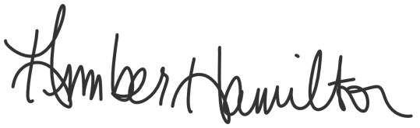
This is to certify that a copy of this agenda was emailed to local and regional media outlets, a copy was provided to the County Clerk’s Office, and posted on the Roosevelt County website www.rooseveltcounty.com by Monday, May 14, 2018 by 5 p.m.

_________________________________________________
Amber Hamilton, County Manager

